Zoom Quick Reference Card for Meeting Hosts
Default Zoom Interface (upon meeting entry)
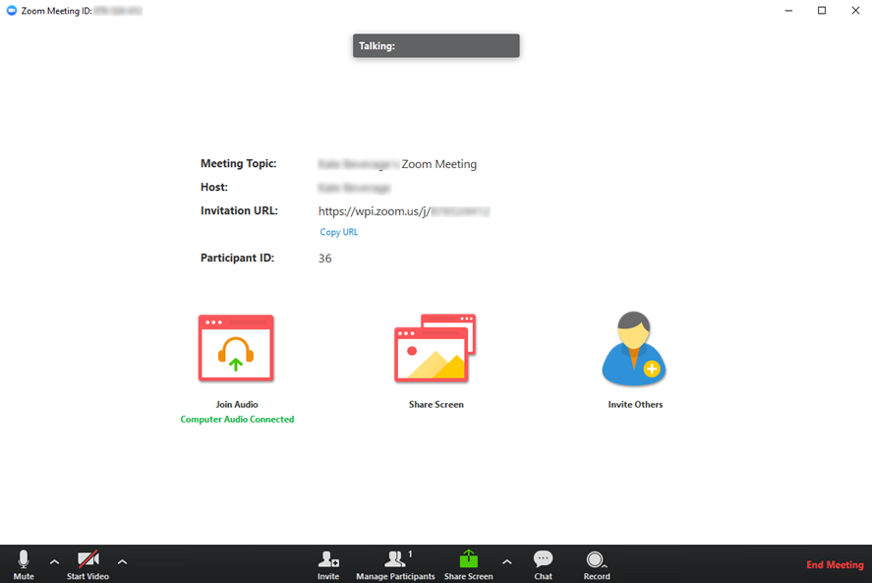
Manage Participants
View and/or manage participants joined to your meeting
Share Screen
Use the controls at the bottom to enable additional sharing options
Record Meeting
creates a local recording on your computer. Contact atc-ttl@wpi.edu for information on how to share this recording with others.
Mute computer audio / share webcam video
Join Audio
Join meeting audio or change audio connection method here
Expand Chat panel pa

Join Meeting Audio
To join the meeting audio, go to Join Audio > Start Meeting Audio. Select the appropriate computer and/or telephony tab to connect your audio.

Managing Participants
You can manage participants by hovering over their name in the Manage Participants panel and expanding More.

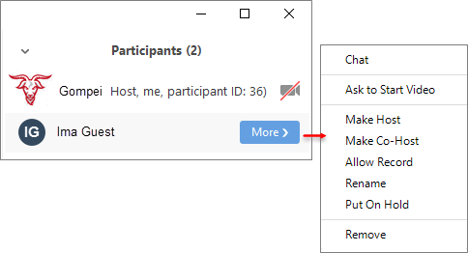

Screen Sharing
- Share your entire screen, a specific application, window, or a whiteboard space by clicking the Share Screen button in the Zoom toolbar or main share area.
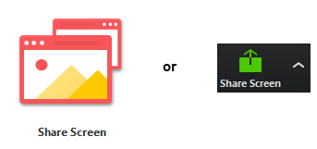
- Select the window or application that you want to share when prompted and Share Screen.
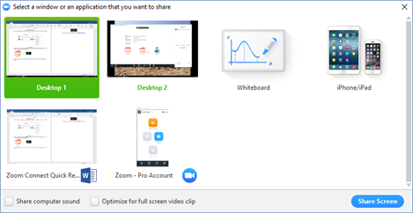

- Use the Share controls to annotate your shared content, access the chat and participant panels, or to pause/stop sharing.
For technical support, contact 888-799-9666 ext. 2 or https://support.zoom.us/hc/en-us/requests/new to submit a ticket.

