Fictional SYNC Session for Participation

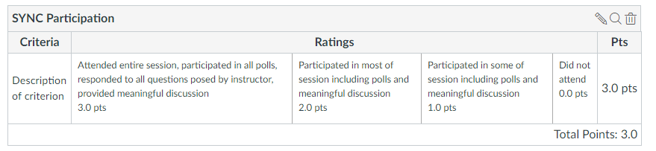

Student #5 (Tyrion Lannister)
FULL CREDIT (3)
- Arrives before session starts recording
- Is online at end of recording
- Provides meaningful responses to all questions and responds to other students
- Responds to all polls

Student #4 (Leslie Knope)
FULL TIME, NOT ALWAYS RELEVANT (2):
- Arrives before session starts recording
- Is online at end of recording
- Provides short responses to all questions (not meaningful, no critical thinking)
- Responds to all polls
- Some responses are not relevant to the topic (about weather, sports, etc.)

Student #3 (Luke Skywalker)
FULL TIME, MISS ONE POLL (2):
- Arrives before session starts recording
- Is online at end of recording
- Provides good responses to all questions, maybe responds to another student
- Responds to polls #1, #2, and #4 (misses #3)

Student #2 (Hermione Granger)
FULL TIME, MISS ONE POLLS, MISSES DISCUSSION ABOUT TWO POLLS(1):
- Arrives before session starts recording
- Is online at end of recording
- Is online, but not participating during middle of session
- Responds to polls #1, #2, and #4 (misses #3)
- Provides good responses to questions about polls #1 and #4
- No response during discussion about polls #2 and #3

Student #1 (Donald Duck)
LATE, LEAVE EARLY (1):
- Arrives late, after poll #1 and discussion, in time for poll #2
- Drops off early, answers poll #4, drops off before discussion about poll #4
- Responds to polls #2, #3, and #4 (misses #1 because comes in late)
- Provides short responses to questions about polls #2 and #3
- Drops off before discussion about poll #4

Adobe link: https://connect.wpi.edu/r60kxok5xh9/

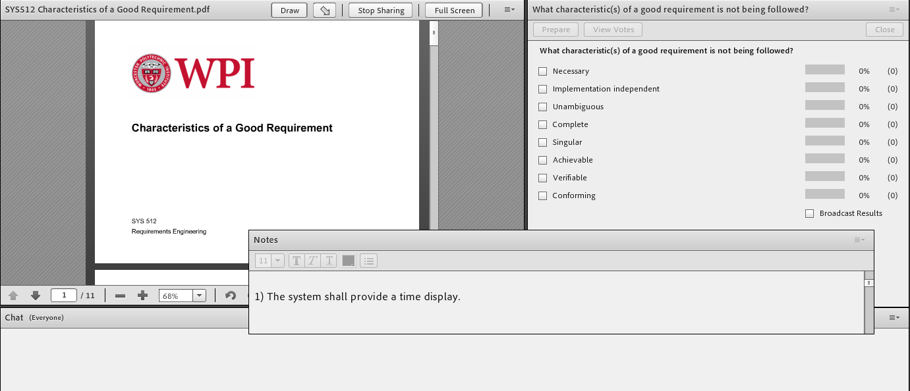

Polls are already established in Adobe that show a list of multiple answers to the question:
What characteristic(s) of a good requirement is not being followed?
- Necessary
- Implementation independent
- Unambiguous
- Complete
- Singular
- Achievable
- Verifiable
- Conforming

Professor: Reminds students of lecture on characteristics of a good requirements. Uses the poll 4 times to ask which characteristics are not being followed. Comments on poll responses with notes shown below in italics. Views responses to see who is missing from polls. Asks for suggestions for better wording.
Poll #1: The system shall provide a time display.
Student #1 not online yet, misses this poll
Students #2, #3, #4, and #5 respond with one or both of the following:
- Unambiguous: Provide a display that includes time or any means to display time (e.g., clock)?
- Complete: Does it display current time, elapsed time, count-down? What time zone?
Professor: What would be better?
Student #1 not online yet, misses this discussion.

Student #5: Shall display the current time
Student #2: How it is displayed would be implementation – just what to display
Student #3: Need more than the current time – need the time zone
Student #4: Could be the pitch clock they are talking about for baseball next year.
Student #5: Good point. How about the system shall display the current time in Zulu.

Poll #2: The target position shall be displayed using the algorithm described in appendix B.
All students respond to this poll with one or more of the following:
- Necessary: could be for the algorithm – displaying the target position may be necessary
- Implementation independent: specifies an algorithm
- Unambiguous: what is the algorithm for – the target position or the display? Is the target position current, past, or predicted?
- Complete: refers to appendix B
- Singular: could be for a combination of requirements if it means the display and the algorithm accuracy
- Verifiable: if the algorithm is required for some reason, how do we verify that it was used?
All students answer this poll.

Professor: What would be better?
Student #2 is distracted and does not respond to this question

Student #1: Just need the target, not the algorithm
Student #3: Algorithm seems implementation specific
Student #5: Need to define the accuracy, like plus or minus 1 meter
Student #4: Accurate enough to paint the corners of the strike zone
Student #5: Also need to know if it is current target position or predicted target position.
Student #3: The system shall display current target position plus or minus 1 meter.

Poll #3: The Android battery shall be recharged quickly using an iPhone charger.
Students #2 and #3 miss this poll.
Students #1, #4, and #5 respond with one or both of the following:
- Implementation independent: why an iPhone charger?
- Unambiguous: what is quickly?
- Complete: is there a time requirement for 80% life and 100% life?
- Verifiable: how do we test quickly?
- Conforming: Apple product does not fit Android product – interface is conflicting

What would be better?
Student #2 is distracted and does not respond to this question

Student #1: Need to define quickly
Student #3: Need to be able to test this so need something better for quickly
Student #4: I hate waiting to charge my phone
Student #5: Focus should be on how long to reach a particular capacity. Maybe reach 80% within 1 hour and 100% before 3 hours
Student #3: We can test that.

Poll #4: The drone shall deliver 100 online products before the end of the year.
Student #2 is back
All students respond to this poll with one or more of the following:
- Necessary: deadline for initial deployment better in a SOW than requirements document
- Implementation independent: is the drone part of the design?
- Unambiguous: which year? A test trip or by a regular user?
- Achievable: is the technology in place to make this happen?
- Verifiable: how can this be verified before delivery?
- Conforming: are the laws in place to support this?

What would be better?
Student #1 drops off after answering the poll

Student #5: I don’t think this is a requirement. It sounds like something that belongs in a statement of work.
Student #4: I better start my landing pad for my deliveries
Student #3: I agree it isn’t a requirement, maybe a business goal
Student #2: It is defining the implementation by specifying the drones for delivery
Student #5: There are a lot of regulations that need to be in place before this can happen.

Professor: It looks like we are coming to the end of our time. All in favor of wrapping up the session – raise your hand.
Student #1 has dropped off.
Remaining students use the drop down to indicate raising their hand (or some other icon)
End recording

