Fictional SYNC Session for Discussion

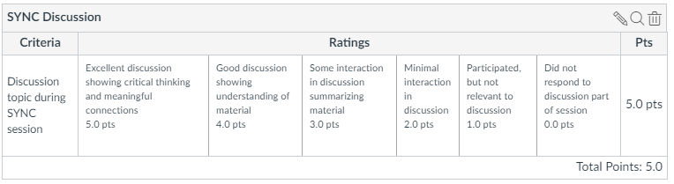

Student #3 (Luke Skywalker)
EXCELLENT (5):
- I’ve been on a program where we used modeling and simulation to make sure that the use case would work before we wrote the requirements.
- It was validation because we were trying to make sure the requirement would work in the noise environment we expected.
- [In response to student on screens] That is a good example. It reminds me of home improvement shows where they use computer graphics to show you what the new room will look like, but not a construction view – what it will look like when you walk in.
- [Later in the discussion] Would building a prototype to make sure the maintenance team could move around the equipment once it was installed be considered validation?”

Student #2 (Hermione Granger)
GOOD (4): good contribution to discussion, show understanding of material
- I’ve seen where we did a mock-up of screens to show the user
- It is validation because we were making sure it was right for the operator.
- [In response to student on maintenance prototypes]: The prototype would be a good way to show limitations of movement opening drawers and turning tools.

Student #1 (Donald Duck)
SOME (3): contribute to discussion, summary of content in lecture
- Perform analysis to make sure it meets the user need before the requirement is written.
- Validation where we show that the analysis applies to the intended environment

Student #4 (Leslie Knope)
MINIMAL (2): short answer to question, no response to anything from other students
- A simulation showing a mission thread

Student #5 (Tyrion Lannister)
PARTICIPATED BUT IRRELEVANT (1): post response, but not really an answer
- I read an operational test report once and it showed that there were a lot of problems.

Adobe link: https://connect.wpi.edu/r60kxok5xh9/

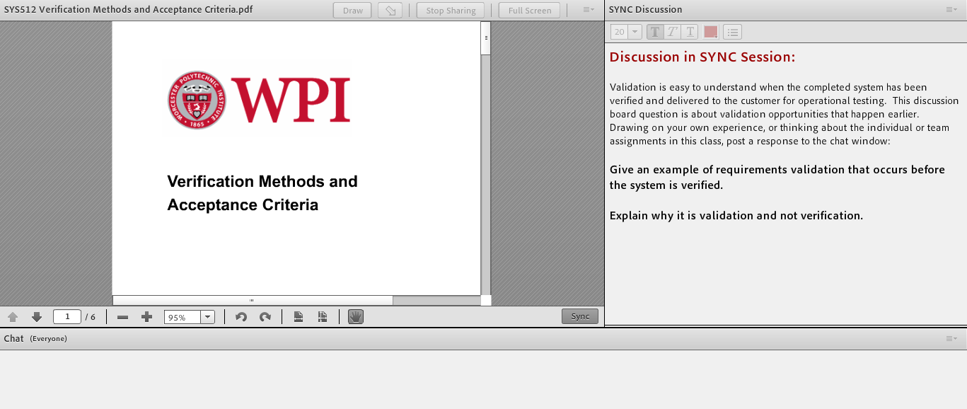

The SYNC discussion is already in a text box and matches the wording in Canvas for the discussion board if it is not completed in the SYNC session.

Professor: Reminds students of lecture on verification methods. Reads the question and asks for responses. Students type their responses and it appears in the following notional chat order:

- Student #3: I’ve been on a program where we used modeling and simulation to make sure that the use case would work before we wrote the requirements.
- Student #3: It was validation because we were trying to make sure the requirement would work in the noise environment we expected.
- Student #1: Perform analysis to make sure it meets the user need before the requirement is written.
- Student #1: Validation where we show that the analysis applies to the intended environment
- Student #4: A simulation showing a mission thread
- Student #2: I’ve seen where we did a mock-up of screens to show the user
- Student #2: It is validation because we were making sure it was right for the operator.
- Student #3: That is a good example. It reminds me of home improvement shows where they use computer graphics to show you what the new room will look like, but not a construction view – what it will look like when you walk in.
- Student #5: I read an operational test report once and it showed that there were a lot of problems.
- Student #3: Would building a prototype to make sure the maintenance team could move around the equipment once it was installed be considered validation?”
- Student #2: The prototype would be a good way to show limitations of movement opening drawers and turning tools.

Professor: It looks like we are coming to the end of our time. The discussion board assignment in Canvas will be closed as completed in the SYNC session.

